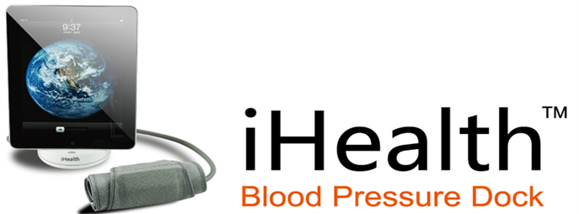
The best mobile platform for personal healthcare

iHealth Lab Inc. CORPORATE FACT SHEET
719 N. Shoreline Blvd.
Mountain View, CA 94043
www.ihealth99.com

Overview iHealth designs and manufactures consumer-friendly, digital personal healthcare products. It’s the first company to design a product that can measure your blood pressure directly with the iPod touch, iPhone and iPad.

Products In January 2011, the company will make the iHealth Blood Pressure Dock commercially available. It is the first product to measure blood pressure with the iPod touch, iPhone, and iPad. The BP Dock attaches to an arm cuff that measures your blood pressure and uploads your data to the iPod touch, iPhone or iPad via the free iHealth Blood Pressure Monitor (BPM) mobile application. The app can be downloaded from the iTunes app store. The software provides a way to test, track, graph and share a history of your blood pressure with your friends, family, and healthcare providers.

Product strategy In 2011, iHealth plans to develop a suite of personal healthcare devices designed for the iOS mobile platform. Future products include a home glucose-monitoring device as well as an iScale. The company plans to focus on delivering easy-to-use products that make it simple for you to test, track, graph and share your health information regularly.

Company background iHealth Lab, Inc. is based in Mountain View, California. It is 100 percent owned by Andon Health Co. Ltd., a global supplier of medical equipment and personal health appliances including blood pressure monitors, blood glucose monitors, digital ovulation meters, portable ECG monitors, etc.

Founded in 1995, the company designs, manufactures, and sells 75 types of health care products in more than 50 countries including the US, Germany, Italy, Russia, Spain and the Netherlands. France

The company has more than 1800 employees and produces over six million products a year. As of June of 2010, the company is publicly traded on the Shenzhen (China) Stock Exchange (002432:CH).

